**WDOS – Web Development and Operating Systems**

**Assignment**

Rovindu Thamuditha  
 CB014648

Introduction

In this assignment We had to update the webpage we created in the semester 1 using JavaScript. And there we had to create 2 new pages. First page consists of the products available and we can add them to a cart table, add our favorite items to a list and apply them again. And by clicking the Buy now button the user is navigated to the payment page where the user must enter the delivery information and Credit/Debit card details (Since I only have one payment method).

Challenges

The major challenge I faced was the time we spend learning is greater than the time we spend with the lecturer learning it. So most of the time we need to learn things ourselves and if we had a problem we had to discuss it with friends or the lecturer. And also we have to use some specific JavaScript Codes (Can’t use onclick method for buttons in the HTML page).

How I overcame them

When I got stuck in the middle of a problem in the JavaScript, I tried to solve it by myself by going through YouTube videos and etc. When I wasn’t able to do it by myself I asked for help of my friends and lecturers.

Learning Outcomes

By going through the assignment I learned how to use JavaScript to make the webpage more interactive with the users.

|  |  |  |  |  |  |
| --- | --- | --- | --- | --- | --- |
|  | **Test Case** | **User Inputs** | **Expected Outcome** | **Actual Outcome** | **Status** |
| 01 | Increasing the quantity.  (Quantity field) | Number of items and amount in KGs  (For KGs, step is 0.1 and for the items, step is 1) | Increment the value in the quantity field | Increment the value in the quantity field | Pass |
| 02 | Add items into the cart  (Add to cart button) | Clicks the add to cart button | product will add into the shopping cart with the quantity | Items will add into the shopping cart | Pass |
| 03 | Add the cart into favorites  (Add to cart button) | Clicks the add to favorites button, | items in the cart will save in local storage | Cart will save in local storage | Pass |
| 04 | Apply favorites (apply favorites button) | Clicks the apply favorites button | cart which saved in the local storage will load into the shopping cart | Cart will add to the shopping cart | Pass |
| 05 | Cart total update | Increase / decrease the quantity value | cart total will increase / decrease in the cart | Update the cart total | Pass |
| 06 | Remove items from the cart | Set the quantity value to 0 | Item row will be deleted (product will be removed from the cart) | Products from the cart will be removed | Pass |
| 07 | Buy now button | Click the button | Page will redirect to another page where checkout procedure happens | Redirect to the buy now page (checkout page) | Pass |

**Test Case Tables**

Order Page

|  |  |  |  |  |  |
| --- | --- | --- | --- | --- | --- |
|  | **Test Case** | **User Inputs** | **Expected Outcome** | **Actual Outcome** | **Status** |
| 01 | Input fields in forms (Personal/Delivery/payment details) | Input values (text, email, number) | Values will store in storage and user can see the values they entered | Values will store in storage and user can see the values they entered | Pass |
| 02 | Remove button in Order summary | Click the remove icon | Remove the item row from the order summary | Remove the item row from the order summary | Pass |
| 03 | Next button | Click the next button | It will move to the next details page | It will move to the next details page | Pass |
| 04 | Previous button | Click the previous button | It will move to the previous details page | It will move to the previous details page | Pass |
| 05 | Checkout button | Click the checkout button | Popup message will display to the user | Popup message will display to the user | Pass |

Payment Page

Activity Diagrams

Add to table Button

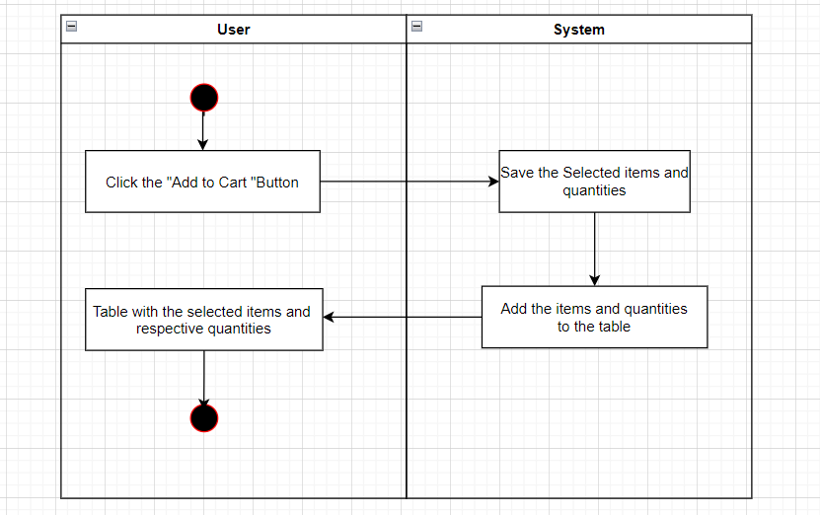

Apply Favorites Button

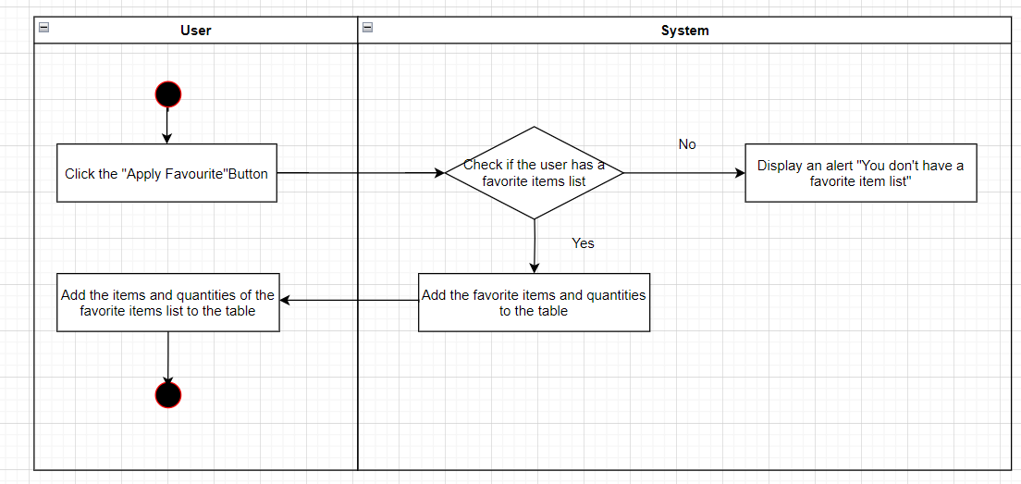

Add to Favorites Button

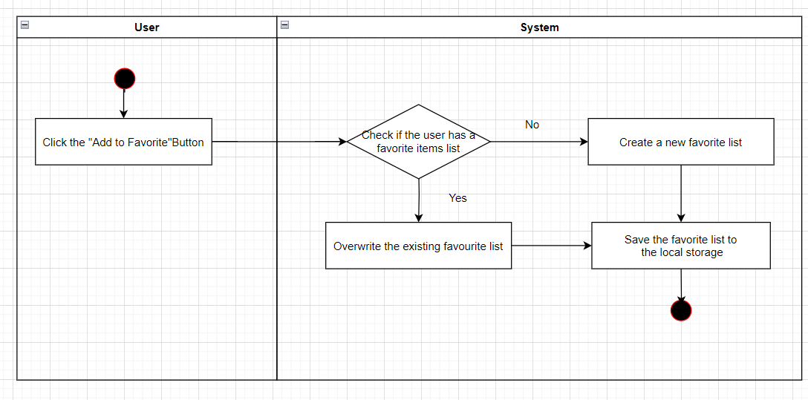

Buy Now Button

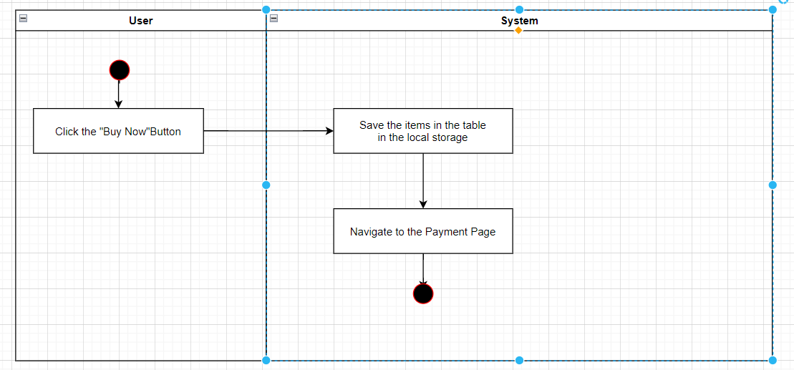

HTML Validations

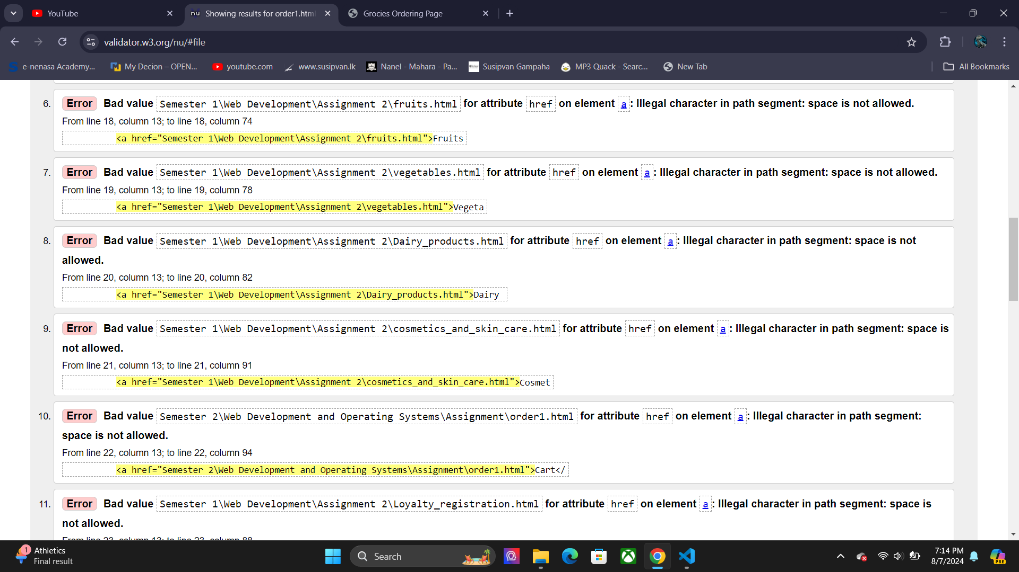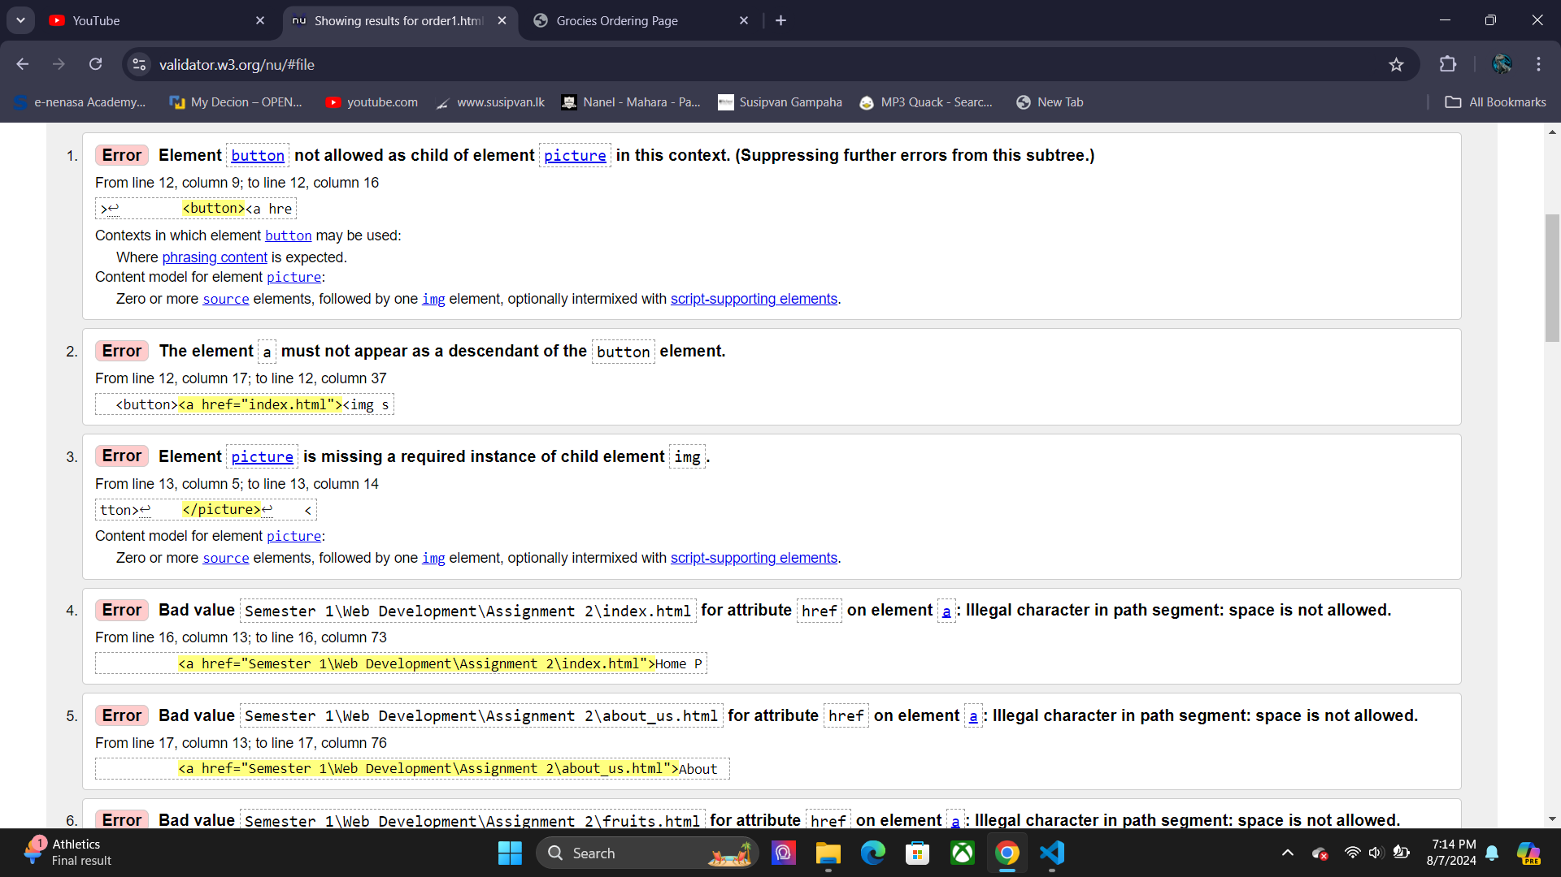 Order1 HTML page

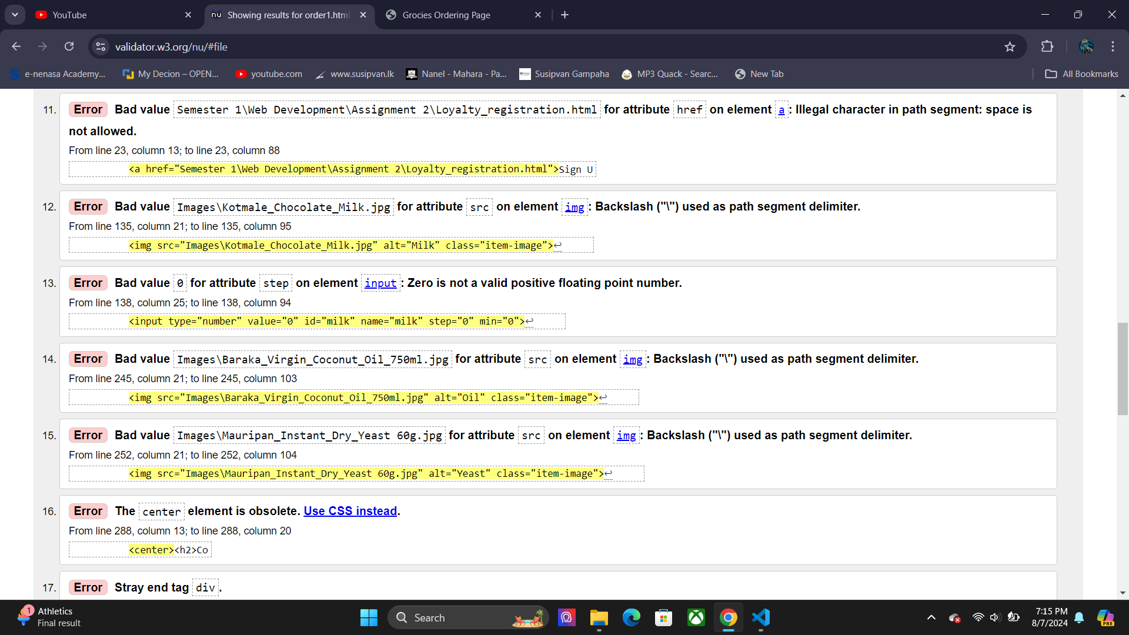

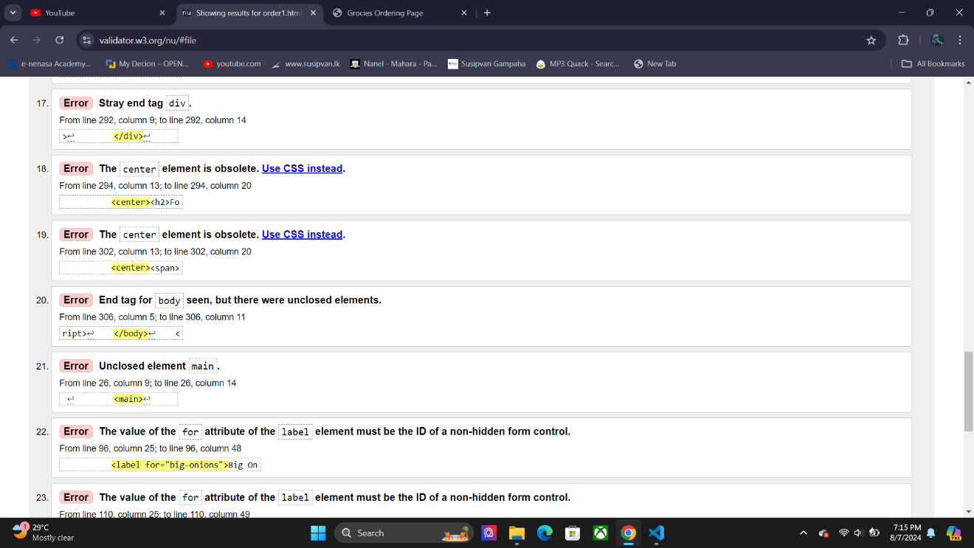

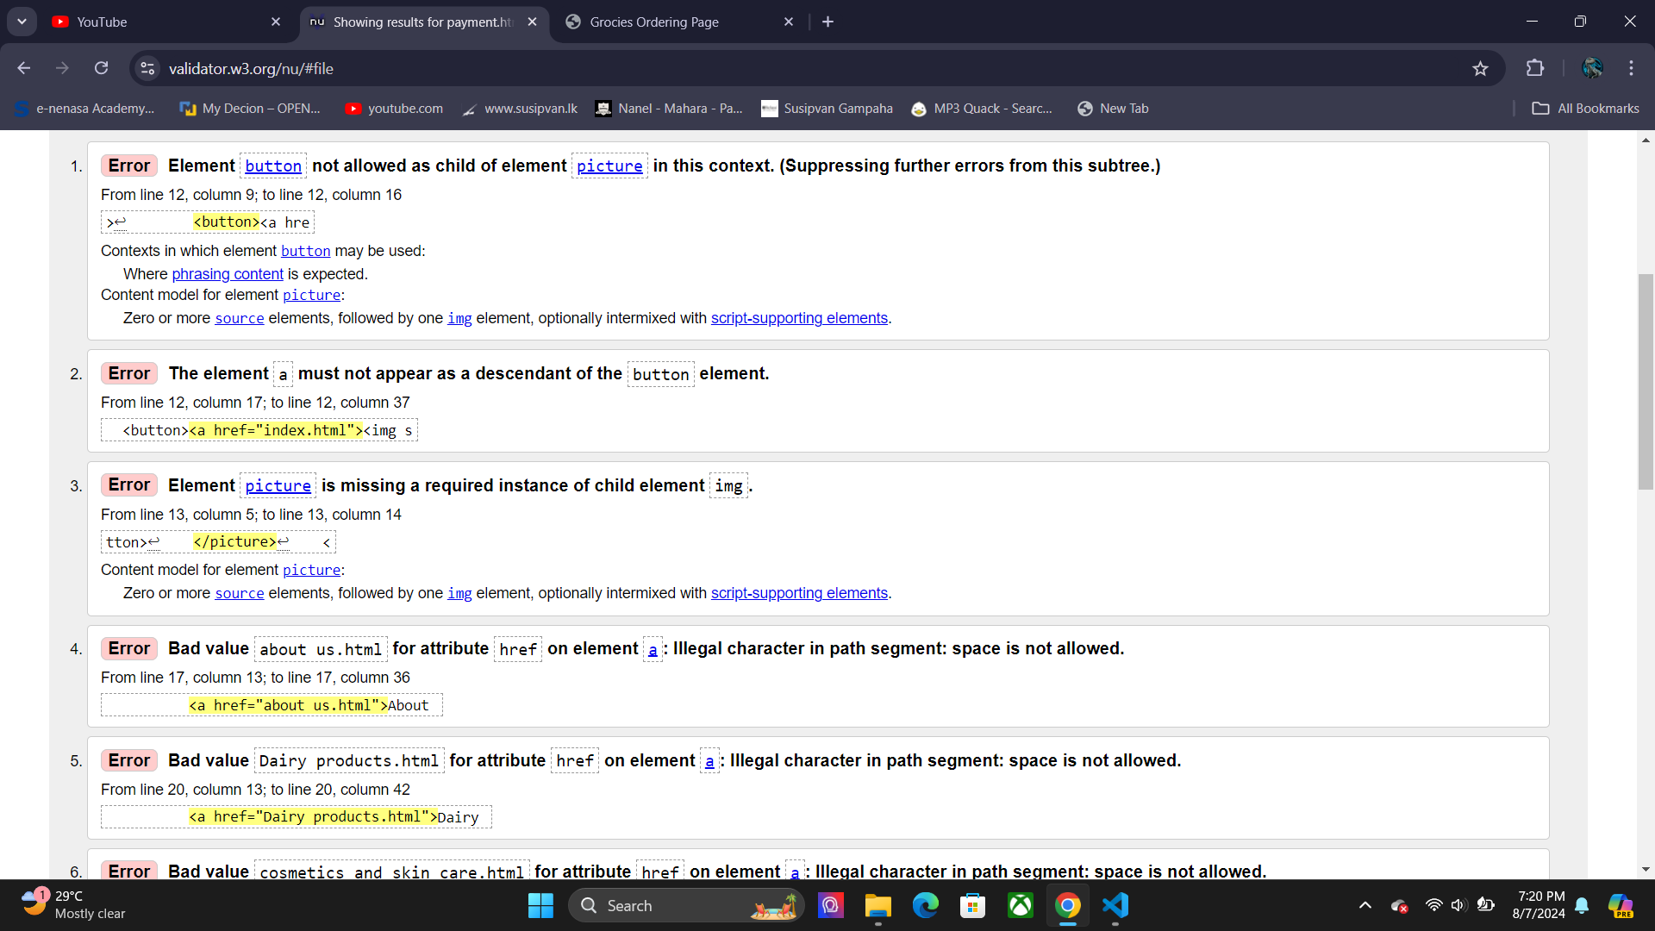Payment HTML Page

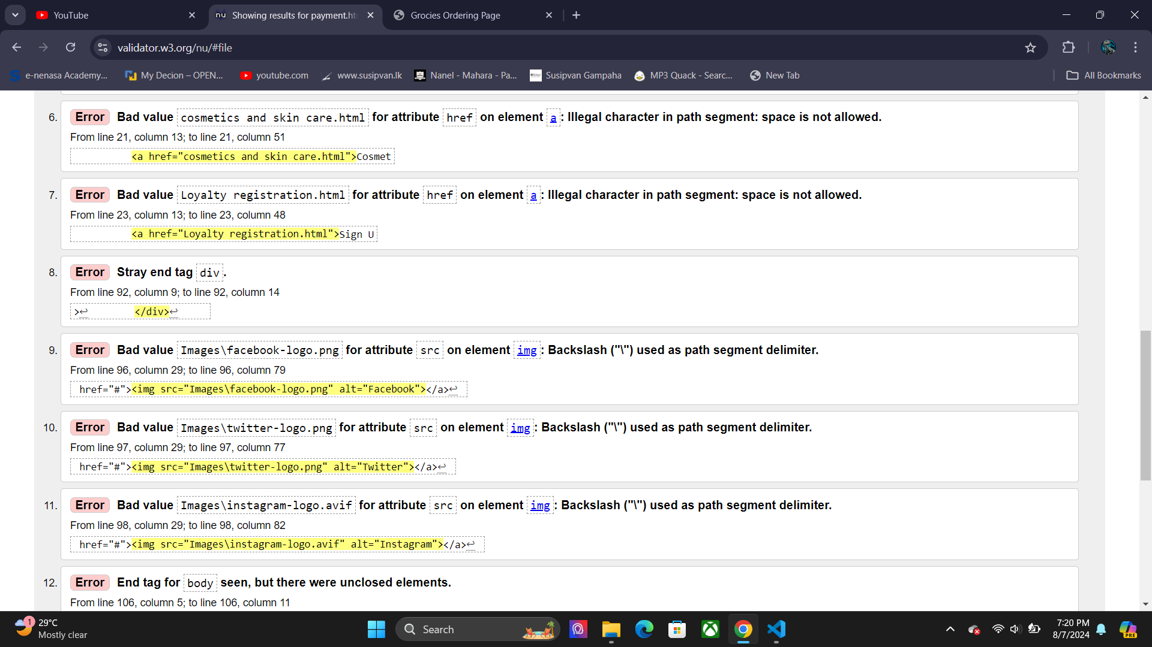

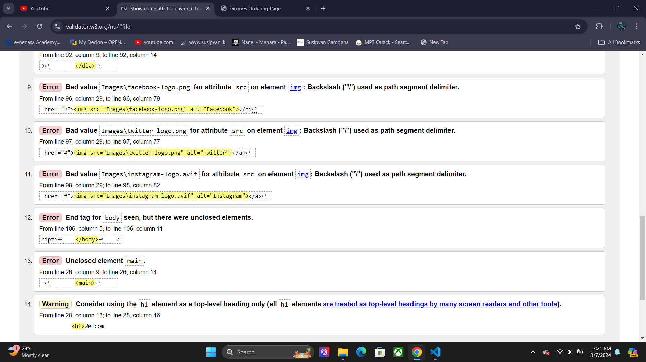

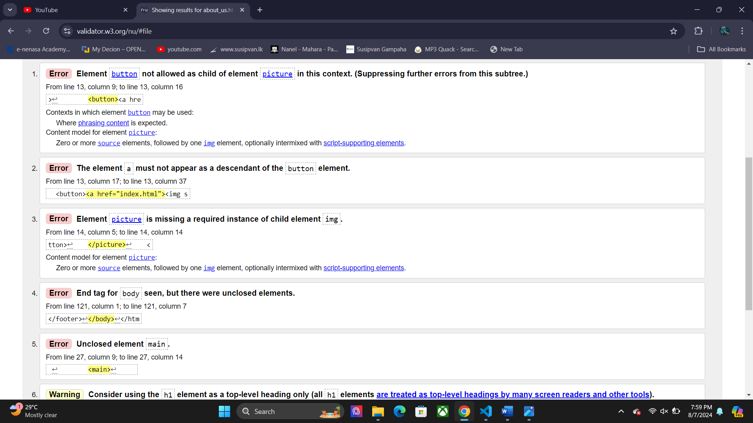About Us Page

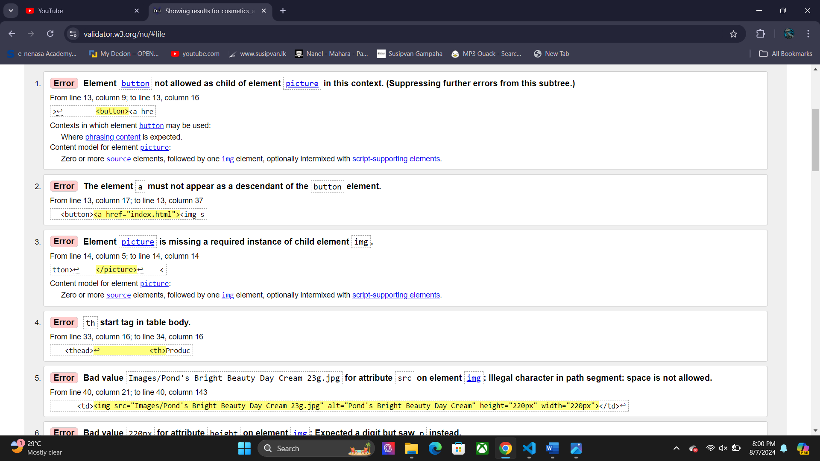 Cosmetics and Skin Care

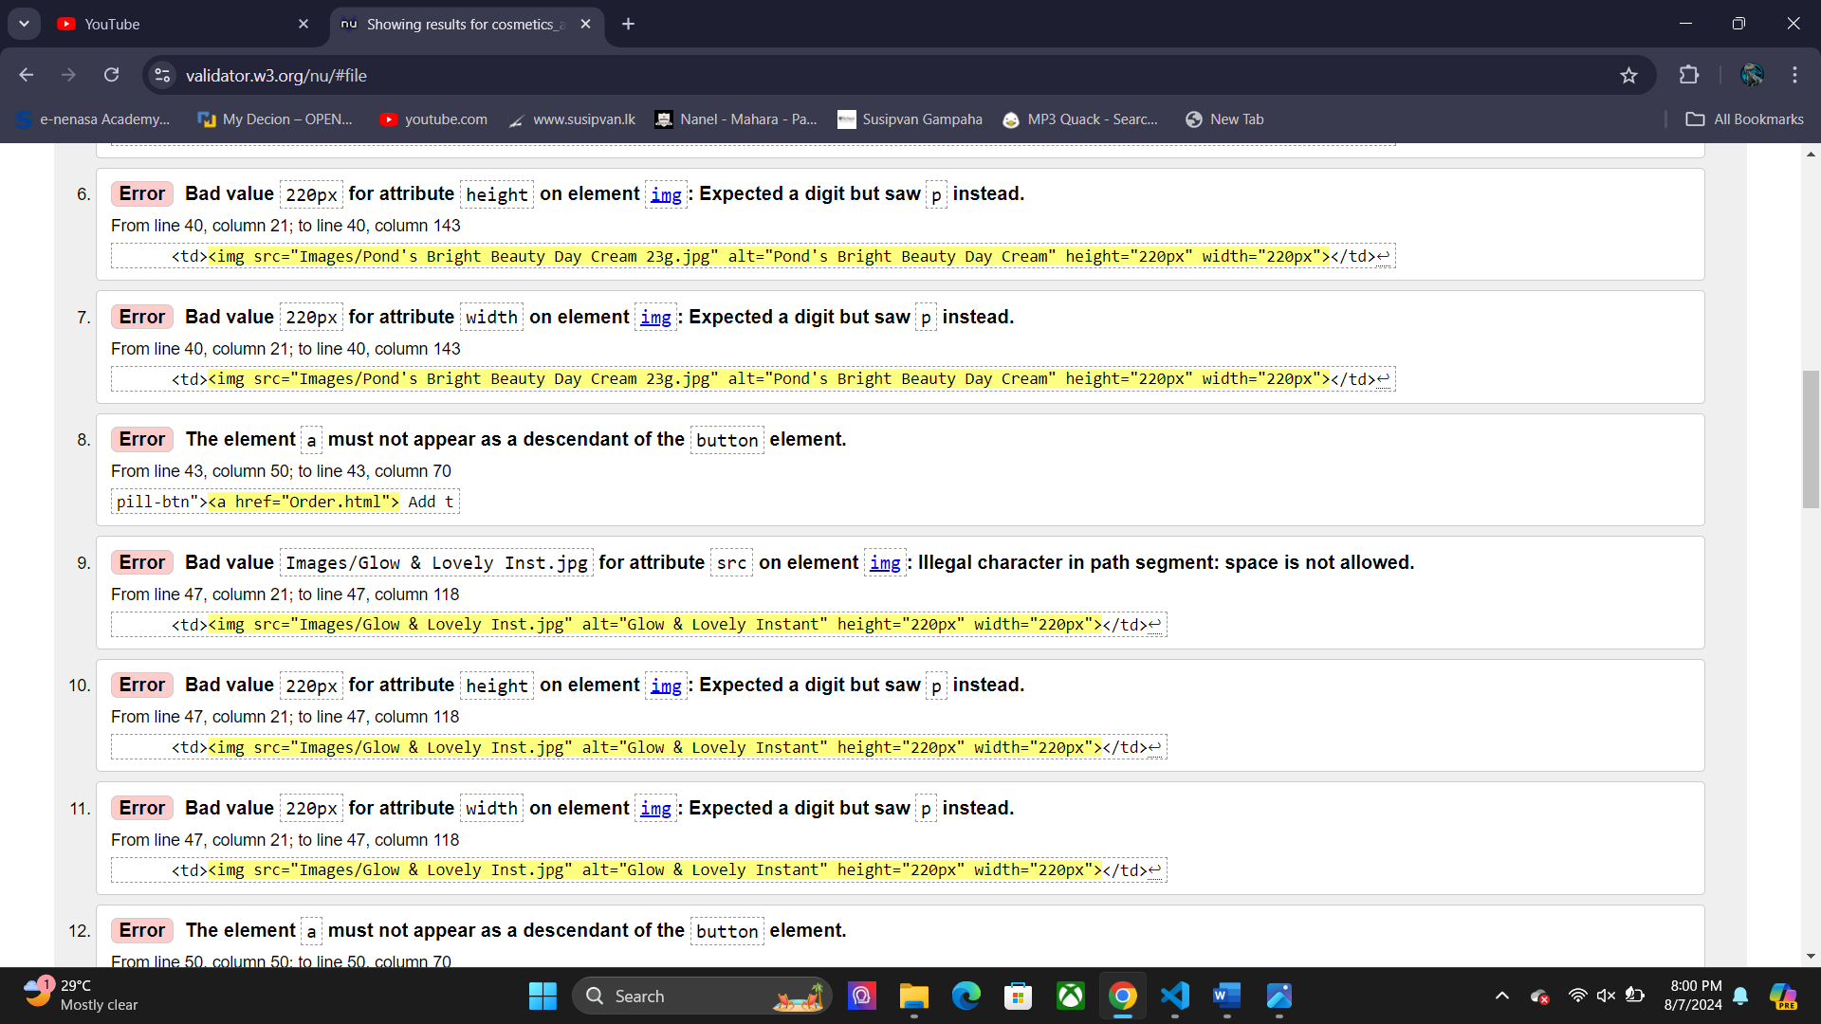

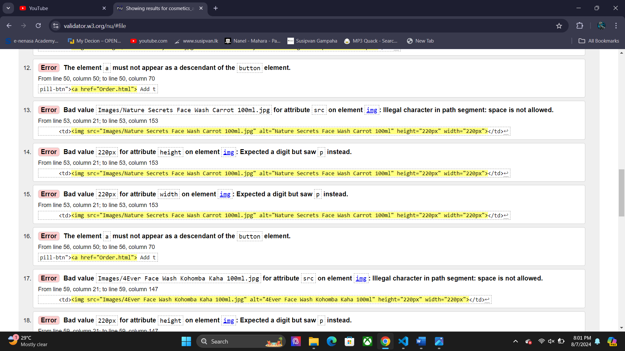

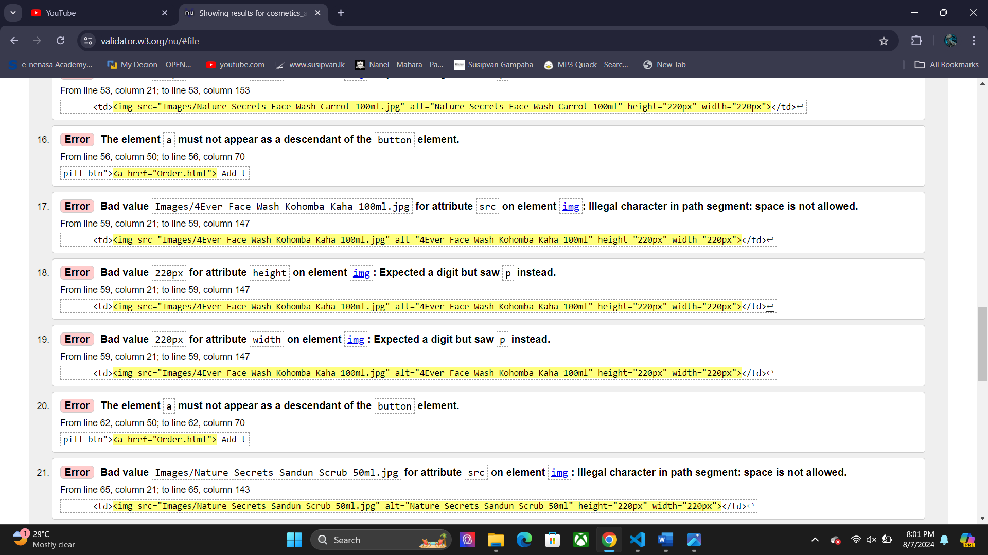

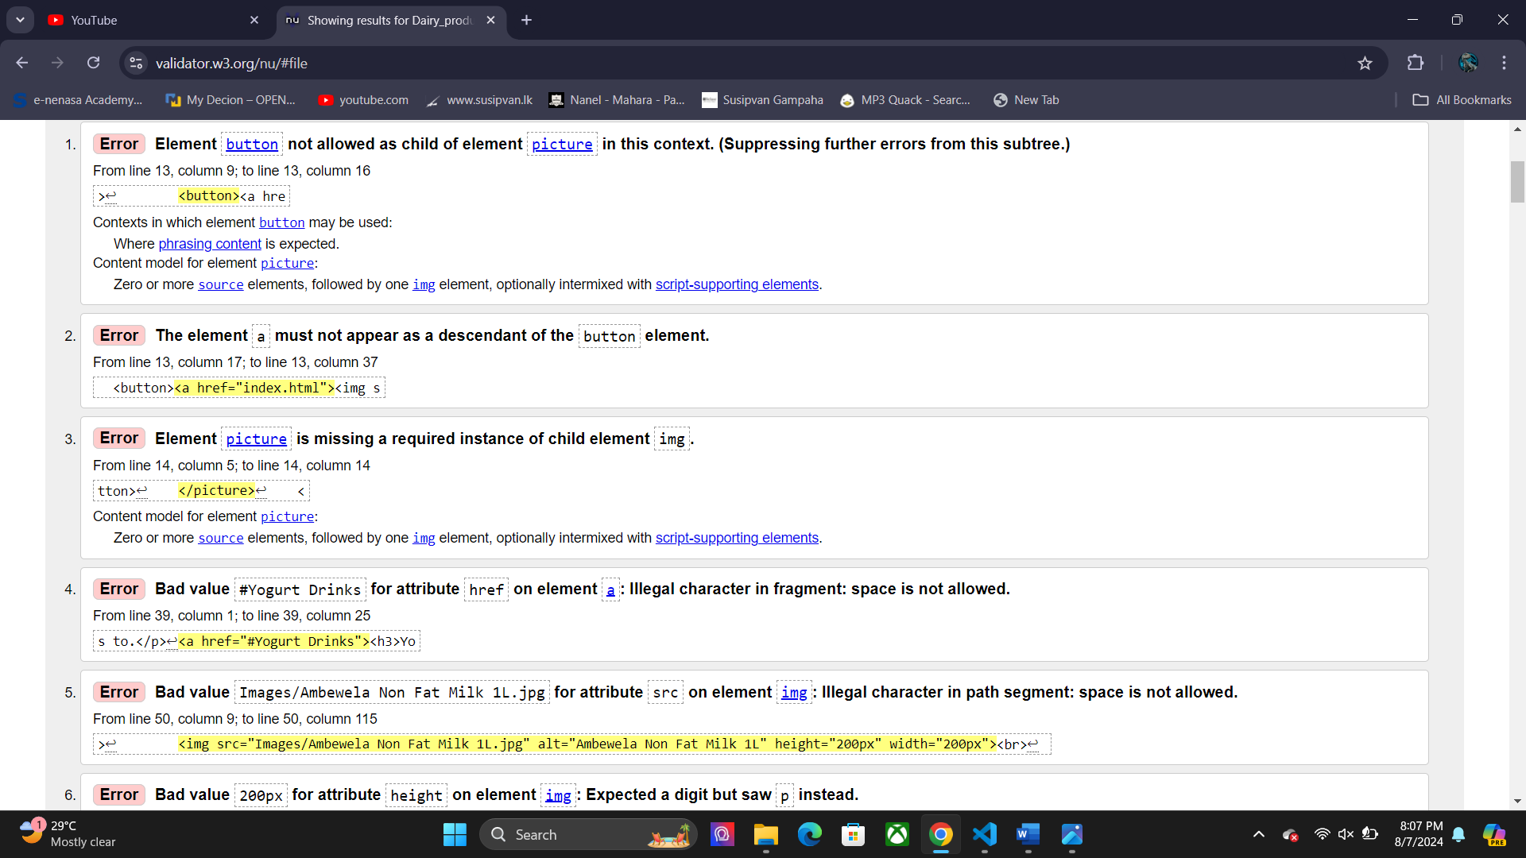Dairy Products Page

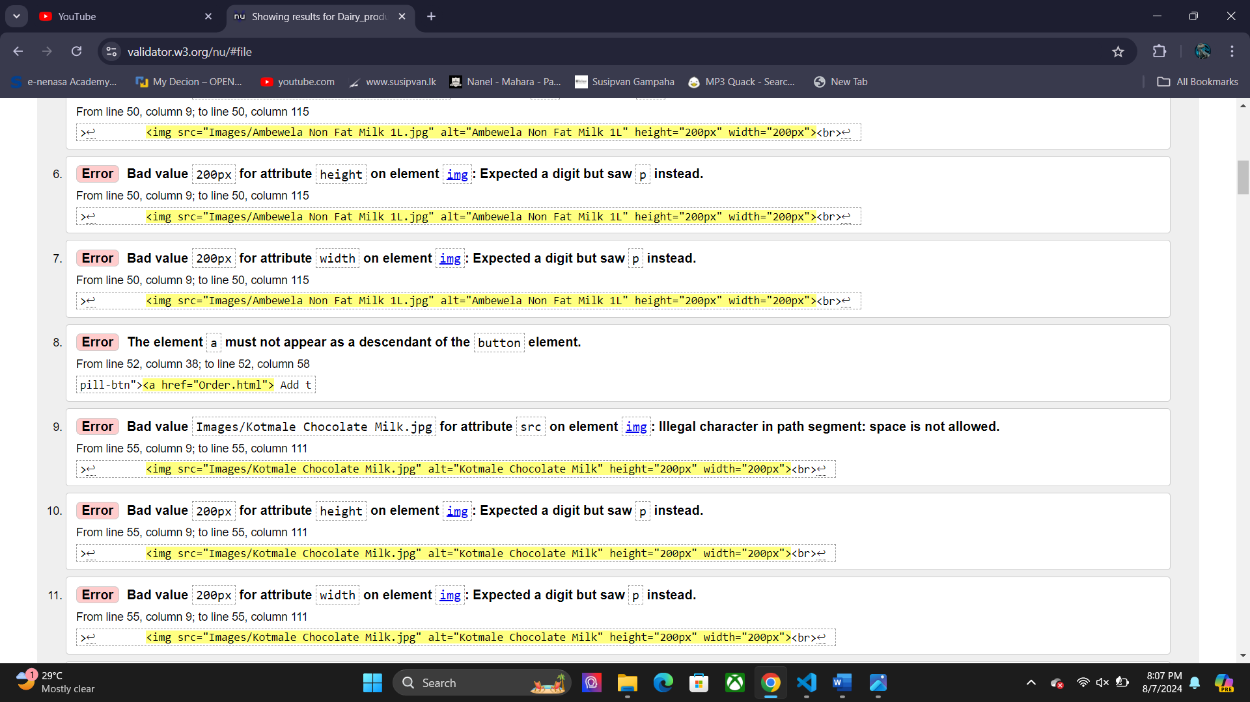

Other Pages Such as Fruits, Vegetables, Loyalty Registration Page, Order Page, Home Page

Have the same set of errors. These errors occur because of using pixel values for image sizes, and using the logo as a button to go to the homepage when clicked.

CSS Validity

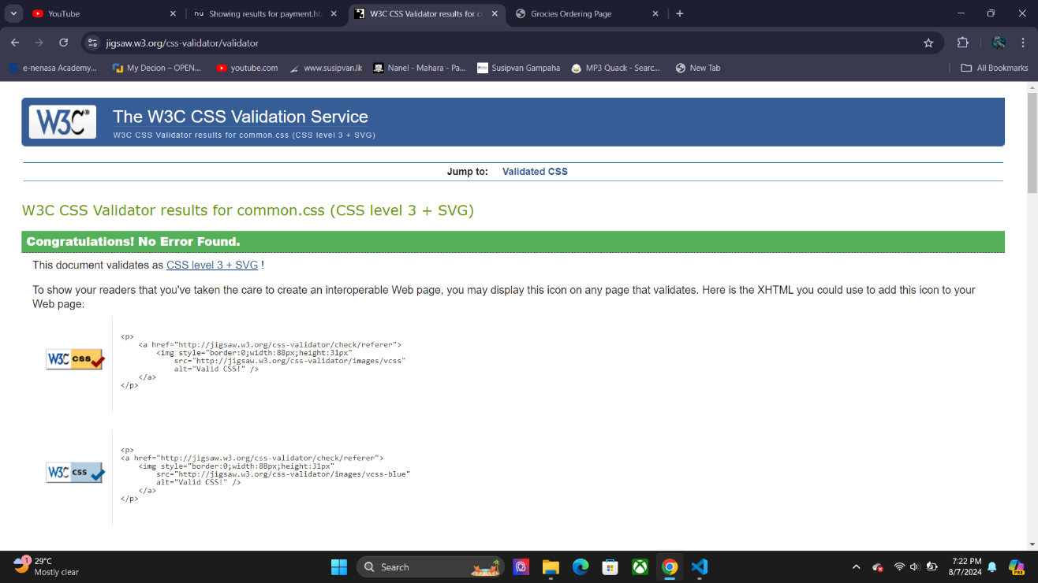 Common Styles Page

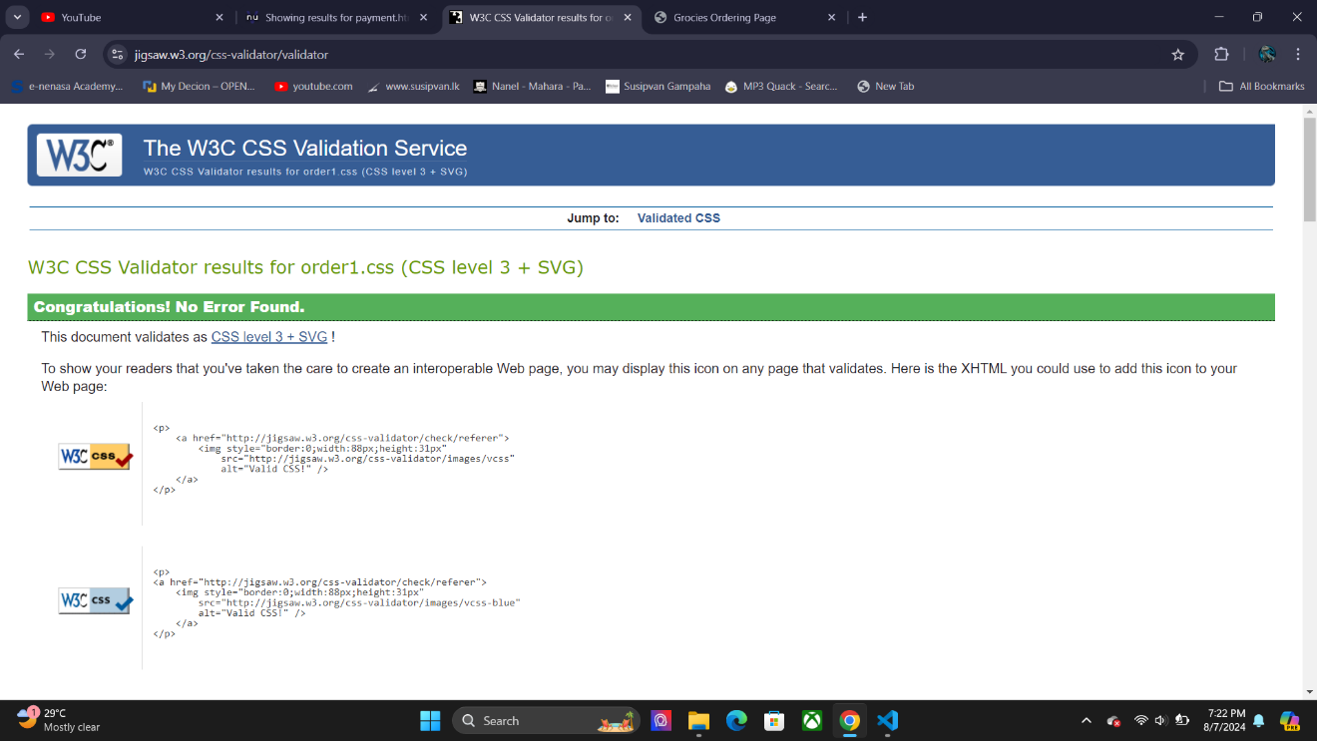 Order1Styles Page

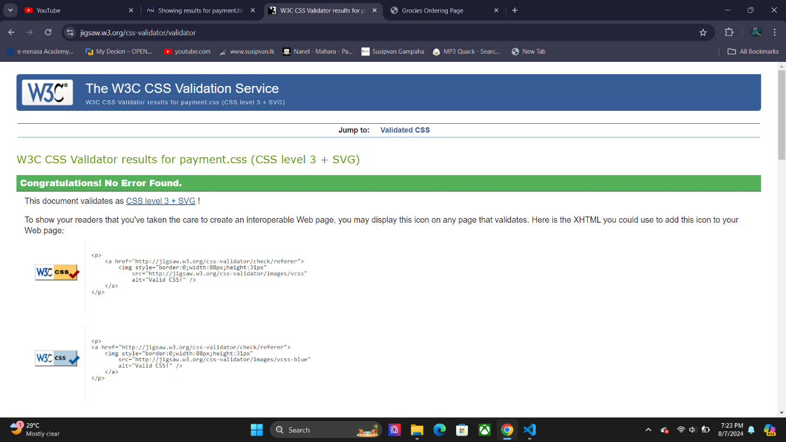Payment Styles Page

About Us Page

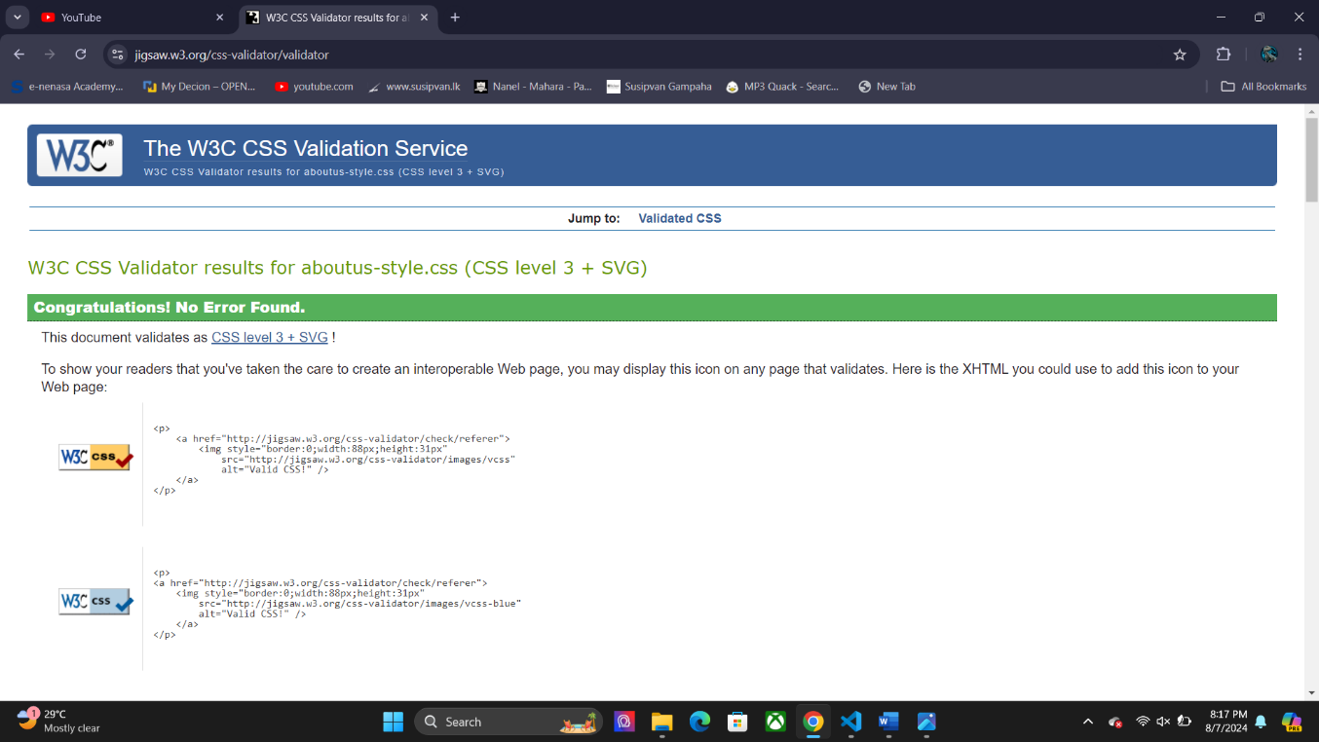

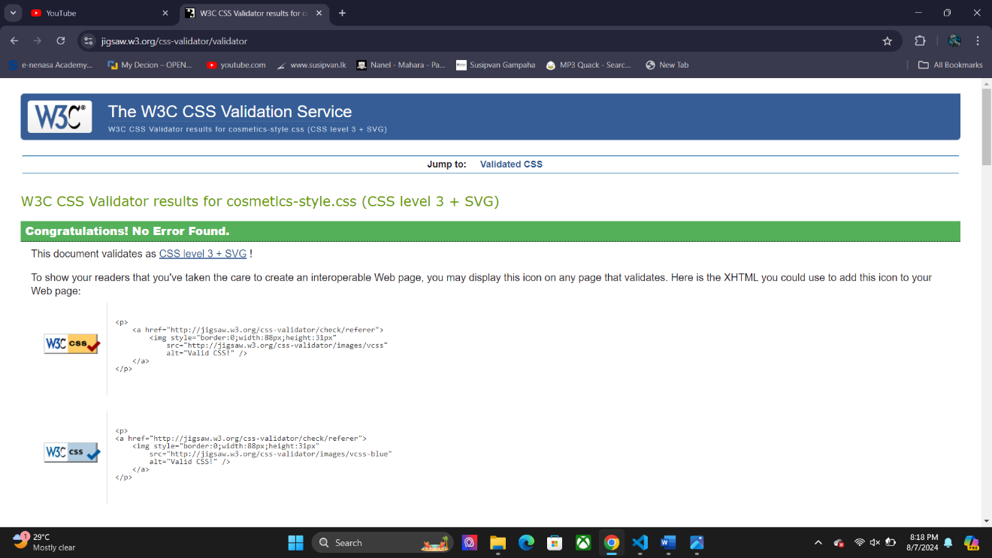Cosmetics and Skin Care Page

Home Page

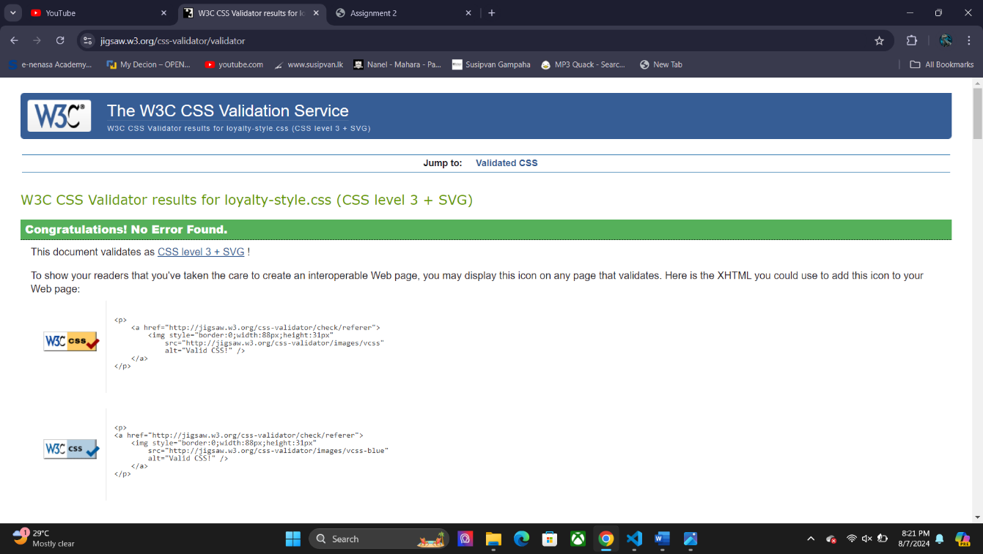

Other Style Sheets have been checked and there are no errors.

Lighthouse Testing

Order1 Page

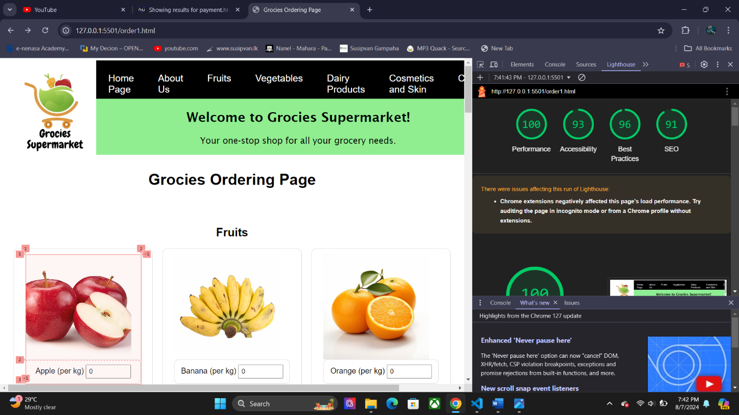

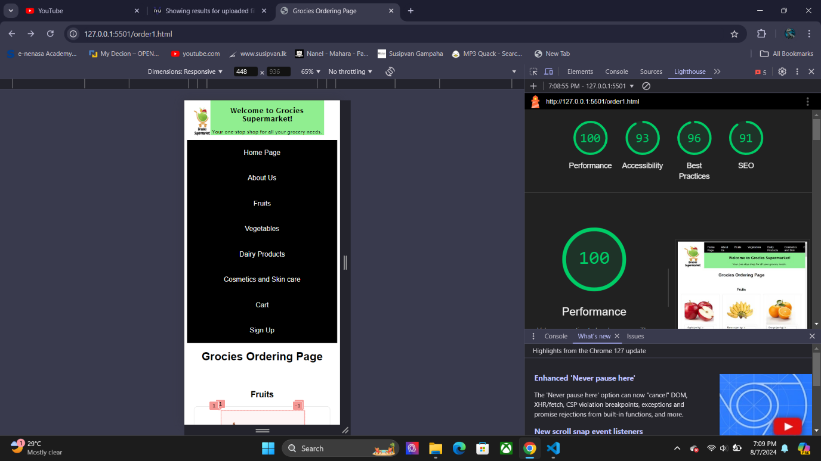

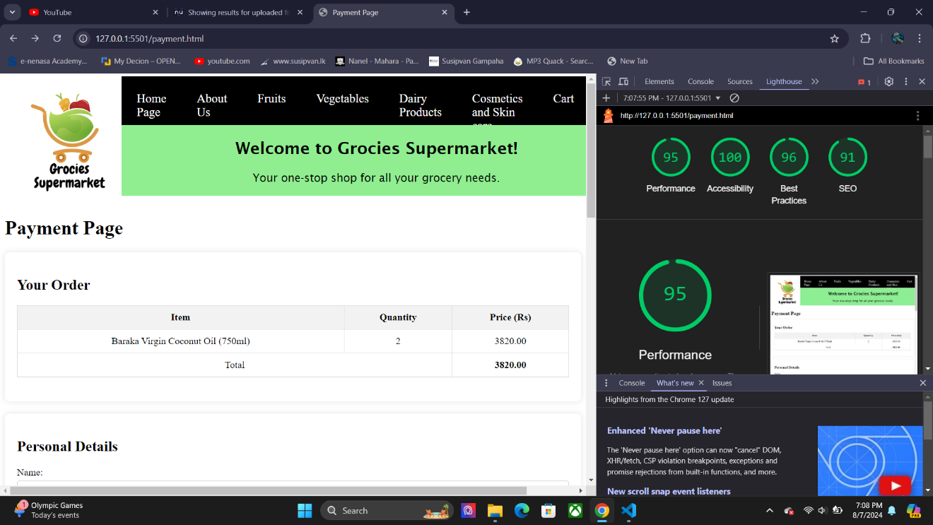Payment Page

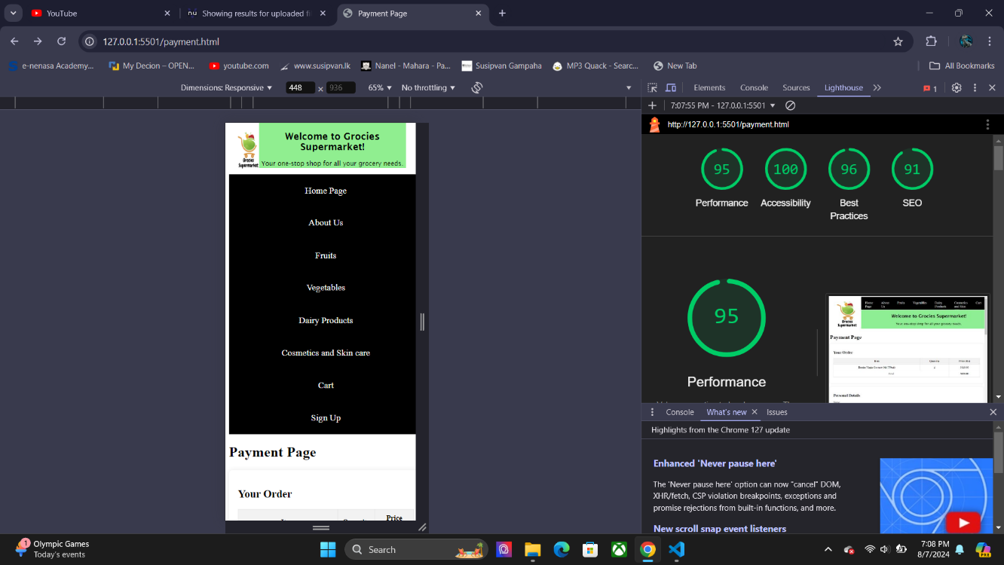

Home Page

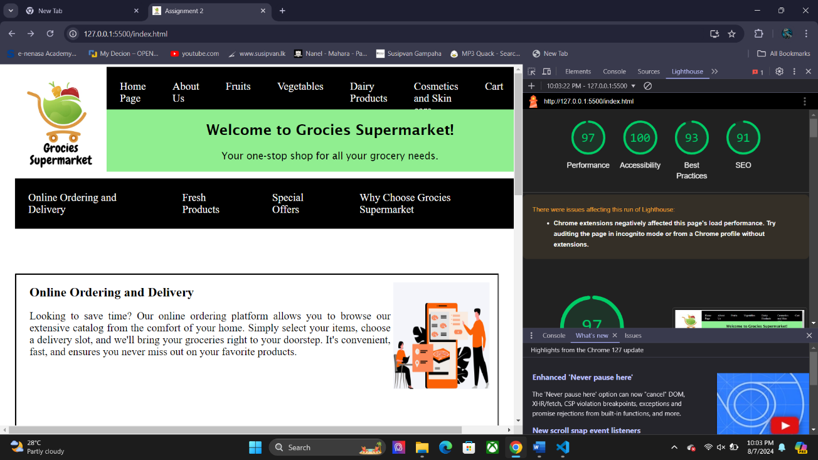

About Us Page

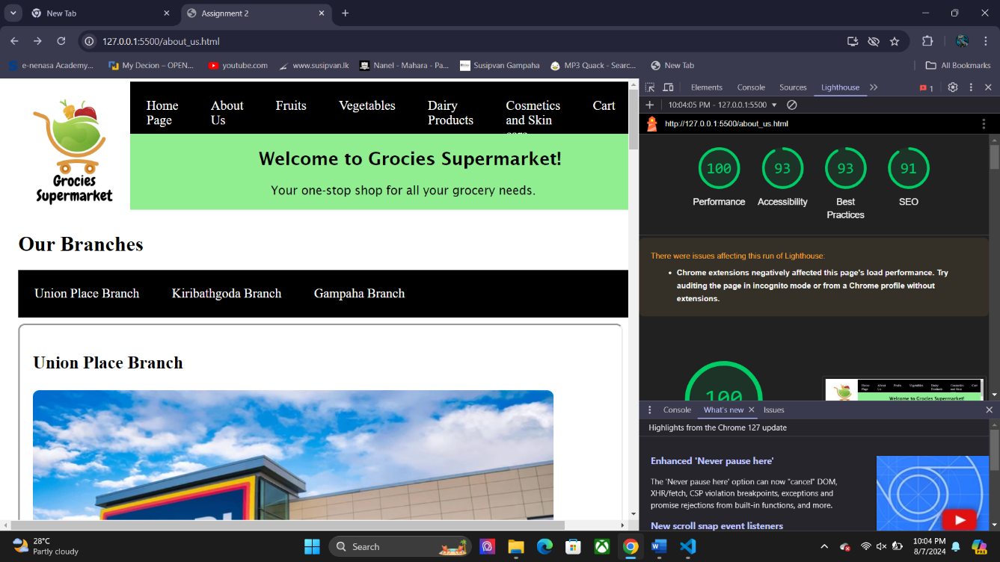

Fruits Page

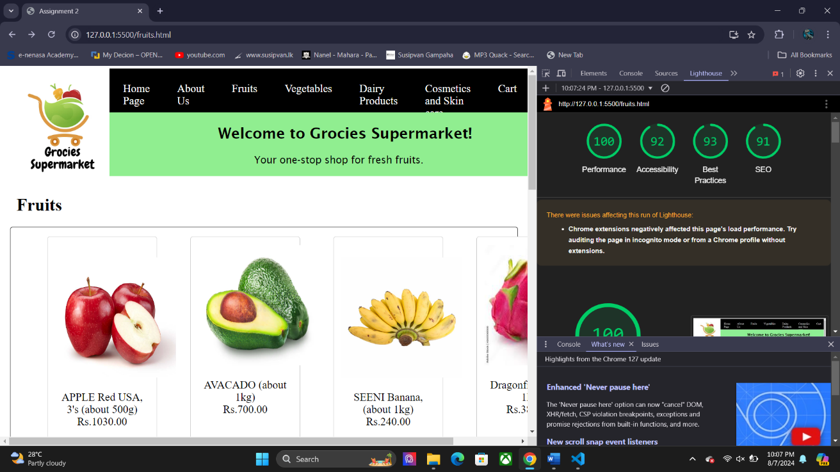

Vegetables Page

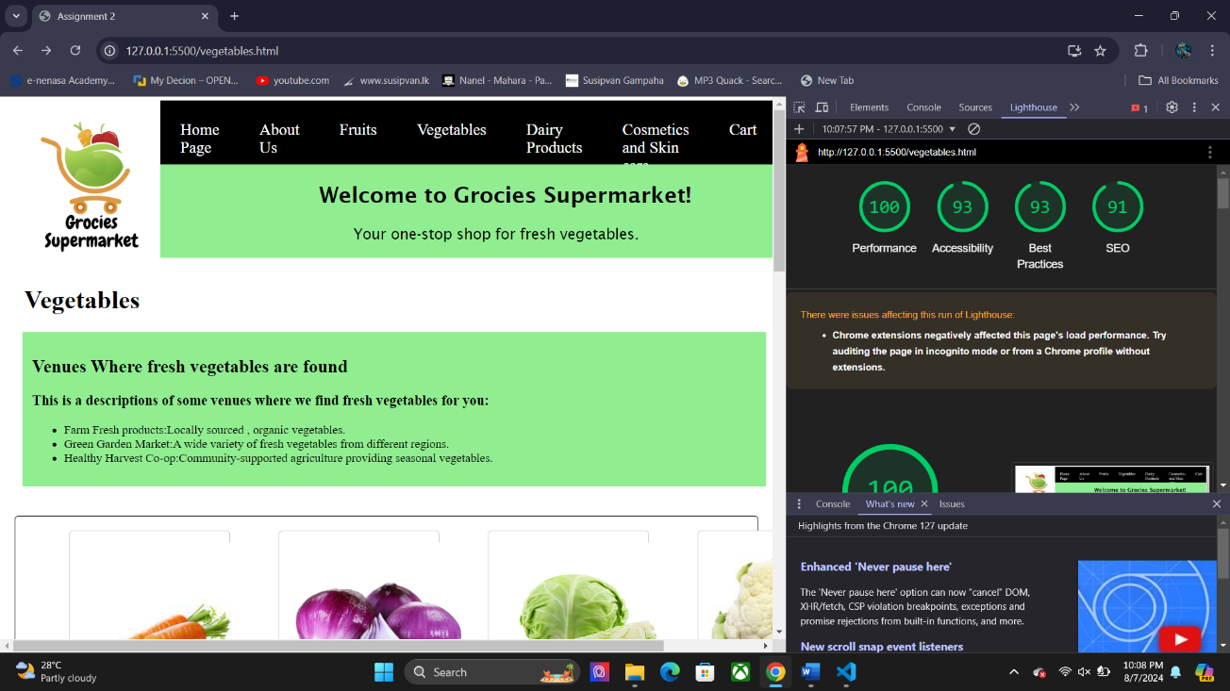

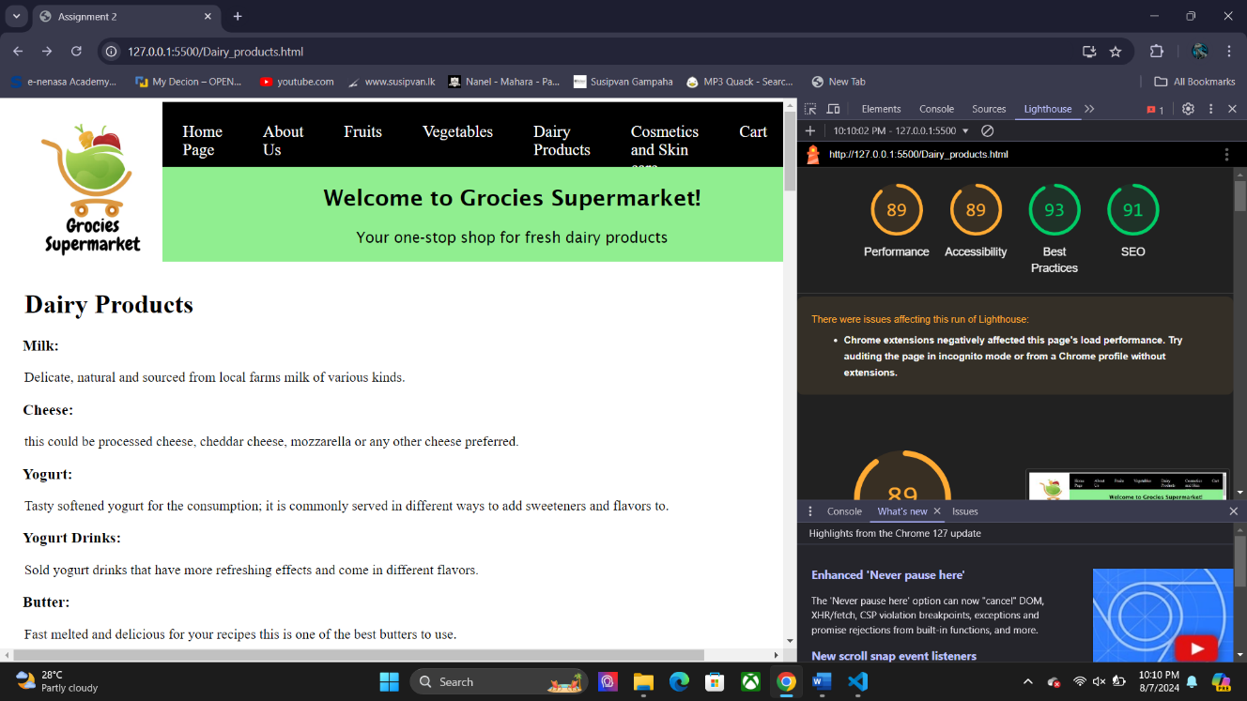Dairy Products Page

Cosmetics and Skin Care Page

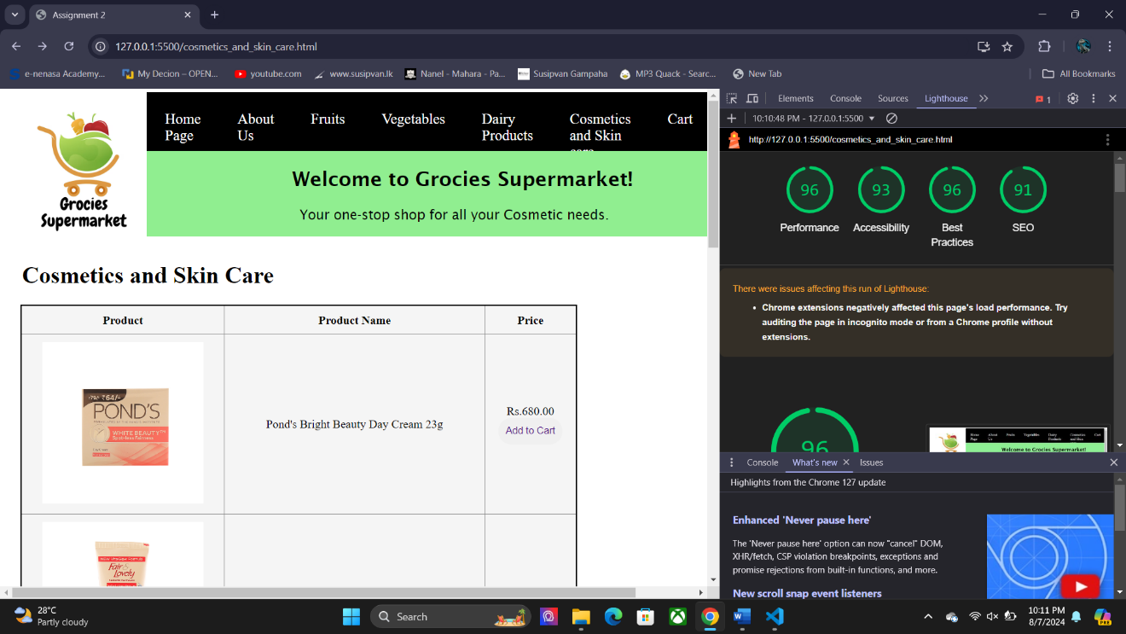

Cart Page

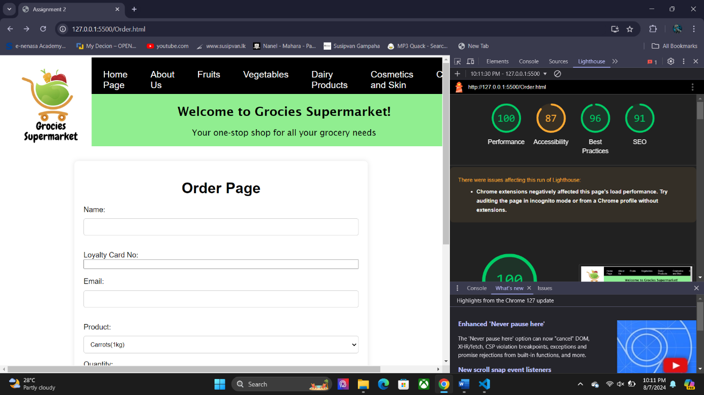

Loyalty Registration Page

